Vivekanand Education Society’s

**Institute of Technology**

**An Autonomous Institute Affiliated to University of Mumbai,, Approved by AICTE & Recognized by Govt. of Maharashtra Hashu Advani Memorial Complex, Collector Colony, Chembur East, Mumbai - 400074.**

**Department of Information Technology** A.Y. 2024-25

Advance DevOps Lab Assignment 01

**Aim:**

Part 1 : To develop a website and host it on your local machine on a VM Part 2 : To host the website developed as part 1 of Assignment 1 using AWS.

|  |  |
| --- | --- |
| Roll No. | 04 |
| Name | Atif Ansari |
| Class | D15B |
| Subject | Advance DevOps Lab |
| LO  Mapped | LO1: To understand the fundamentals of Cloud Computing and be fully proficient with Cloud based DevOps solution deployment options to meet your business requirements. |
| Grade: |  |

**Aim:**

To develop a website and host it on a local virtual machine (VM), followed by hosting a static website on Amazon S3 (AWS).

**Theory:**

**Introduction**

This experiment focuses on website development within a DevOps context, utilizing a technology stack that includes HTML, CSS, and JavaScript, along with frameworks like React or Angular. For backend support, Node.js or Python can be employed. Initially, the website will be hosted in a local development environment, and later, it will be transitioned to Amazon S3 for scalable, cloud-based hosting. This dual approach illustrates the benefits of both local and cloud environments in web development.

**Hosting on a Local Machine Using XAMPP**

**Setting Up a Local Development Environment with XAMPP**

XAMPP is an open-source, cross-platform web server solution stack package developed by Apache Friends. It comprises:

* **Apache**: A widely-used web server software.
* **MySQL/MariaDB**: Robust database management systems.
* **PHP**: A versatile server-side scripting language.
* **Perl**: A high-level programming language.

**Pros and Cons**

**Advantages:**

* **Complete Control**: Developers have full control over their development environment, allowing for customized configurations.
* **Development and Testing**: XAMPP is particularly useful during the development and testing phases, enabling quick iterations.

**Disadvantages:**

* **Limited Scalability**: Local setups may not efficiently handle high traffic.
* **Manual Management**: Developers must manage the infrastructure and updates themselves, which can be time-consuming.

**Hosting a Static Website on Amazon S3 (AWS)**

A static website consists of fixed content primarily built with HTML files and does not require server-side processing. This type of website typically offers improved speed and is easier to host compared to dynamic sites.

**Introduction to AWS S3**

Amazon S3 (Simple Storage Service) is a scalable object storage service that provides a simple web services interface to store and retrieve any amount of data at any time from anywhere on the web.

**Pros and Cons**

**Advantages:**

* **Highly Scalable**: Amazon S3 can effortlessly scale to accommodate growing storage needs, making it ideal for websites with fluctuating traffic.
* **Cost-Effective**: Users pay only for the storage they use, making it a budget-friendly option.
* **Minimal Management**: S3 requires little management, freeing developers to focus on website content rather than infrastructure maintenance.
* **High Availability and Durability**: Data stored in S3 benefits from Amazon’s extensive infrastructure, ensuring high availability and durability.

**Disadvantages:**

* **Static Content Limitation**: S3 is suitable only for static websites, limiting its use for dynamic web applications.
* **Less Control**: Compared to hosting on a VM, there is reduced control over the hosting environment, which may affect certain customizations.

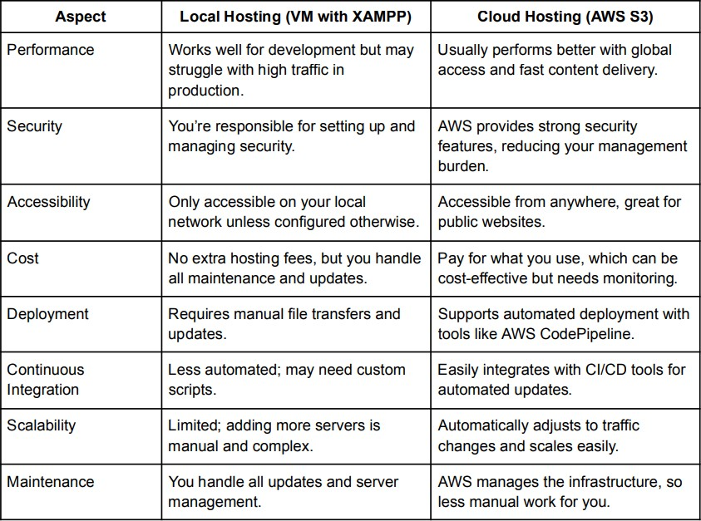

**Hosting on a Local Machine Using Xampp:**

1. Download, Install and Launch Xampp. Start the actions of Apache and MySQL

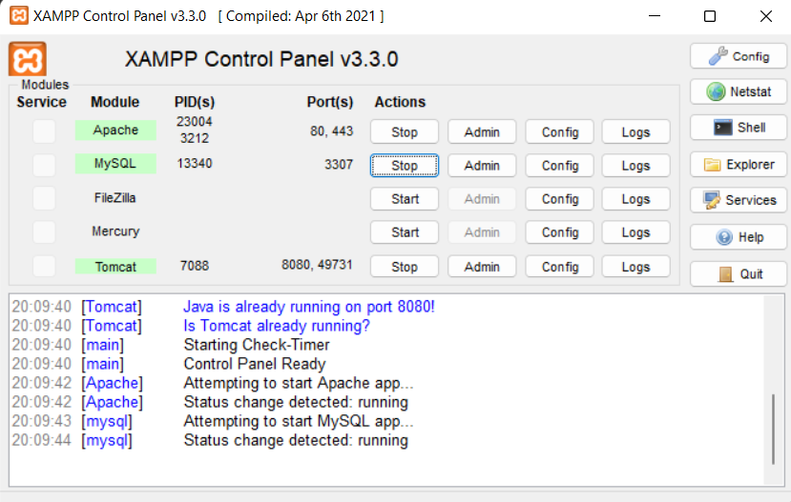

2. Create an index.html and its corresponding css file. Save both files in an appropriate folder as xampp => htdocs => random.html.

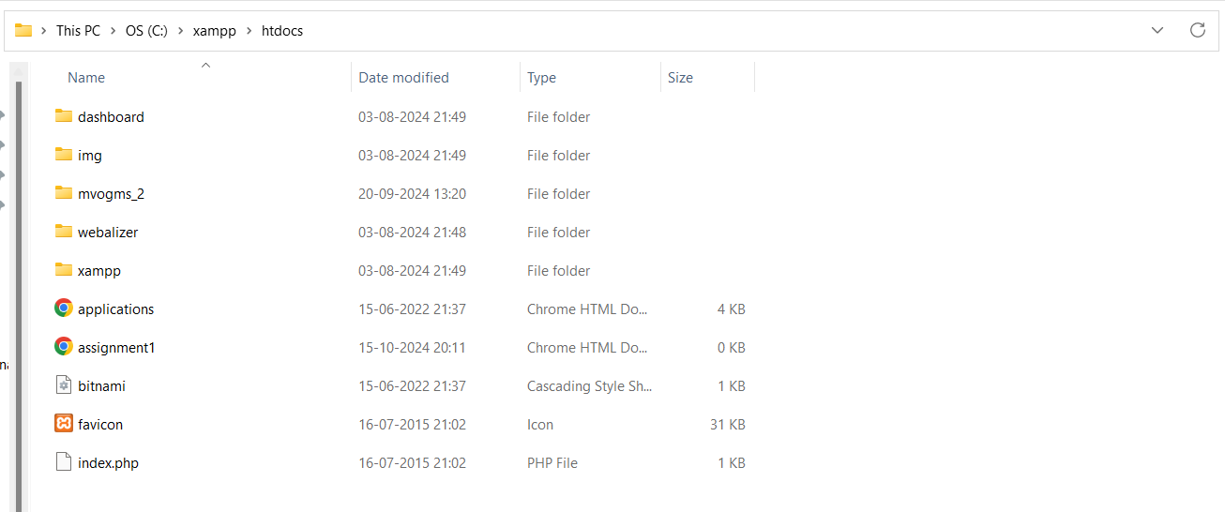

3. Go to any browser and search for <http://localhost/random.html>

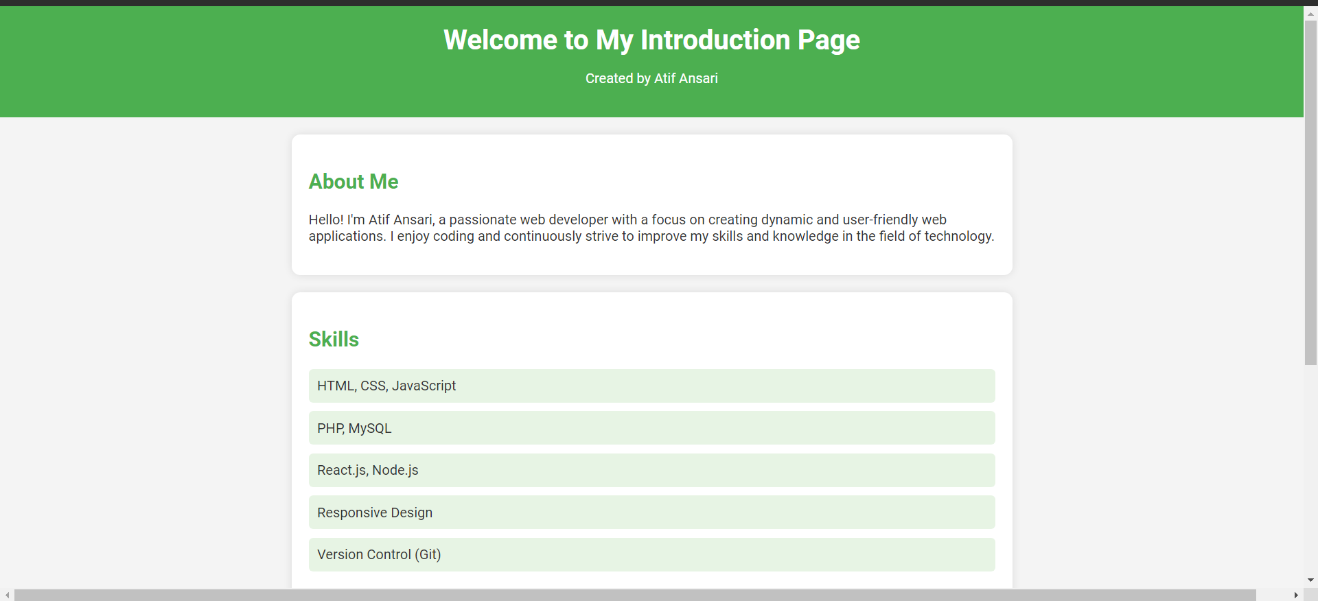

**Hosting a Static Website on Amazon S3 (AWS):**

1. Go to AWS academy website. Solve the Module Knowledge Check. Launch AWS Academy Learner Lab and click on AWS beside the green logo. (logo will become green once the start lab is clicked.)

2. Search for S3 and create a bucket.

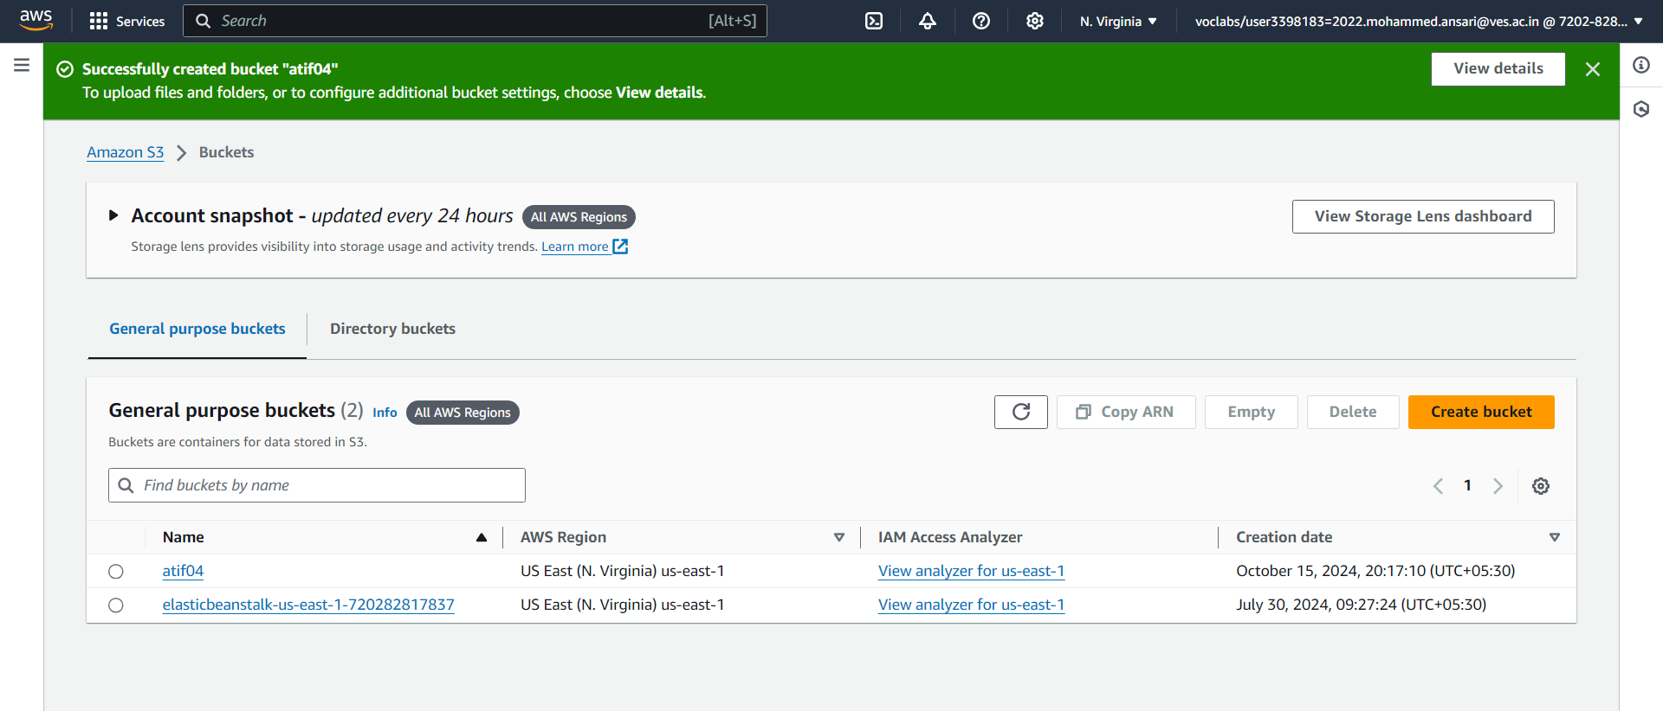

3. Click on the created bucket and upload the index.html and its corresponding css

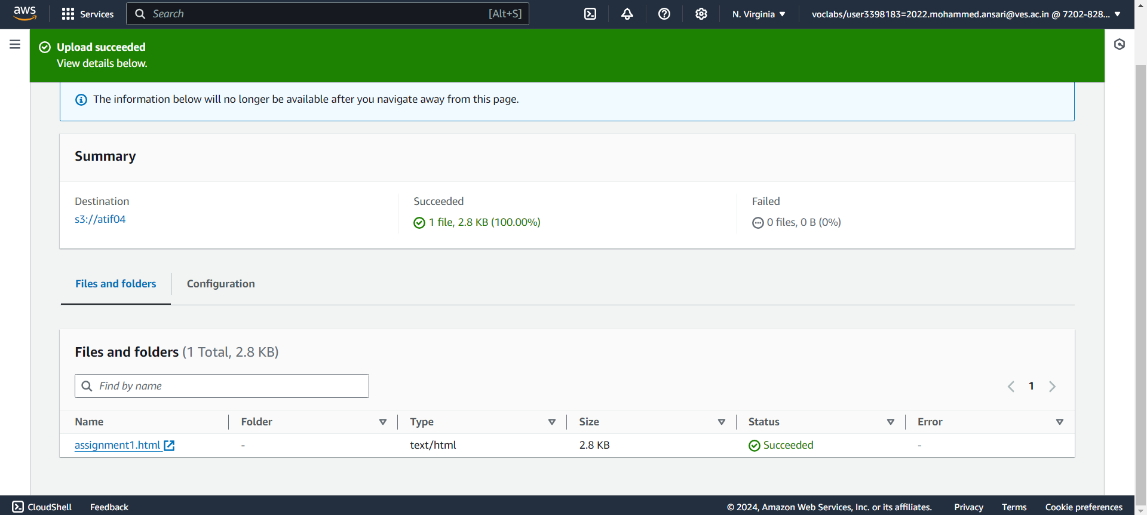

4. Go to the Properties section and enable the static website hosting.

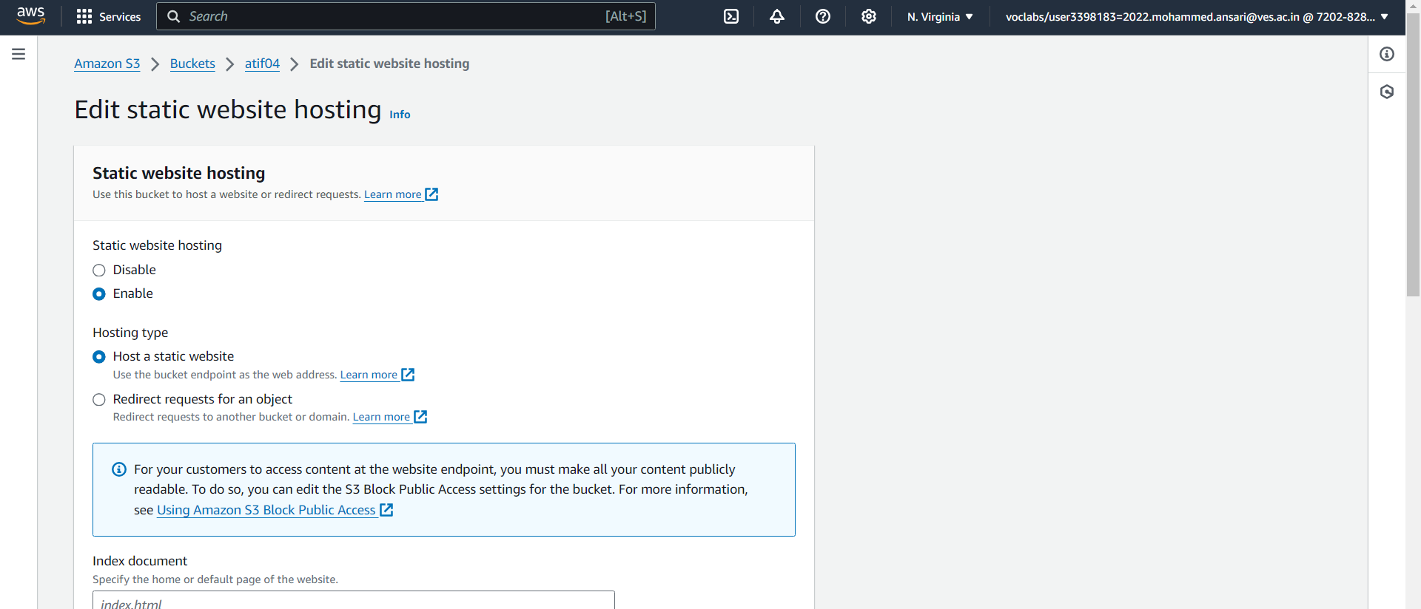

5. Unselect the (main) option of Block public access. (By default, it is selected while creating the bucket). It gives public access to use our website.

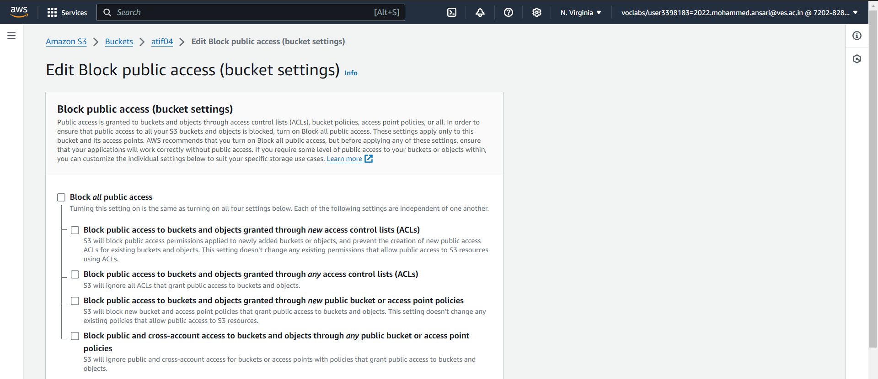

6. Go to the permission section in the new created bucket and edit bucket policy

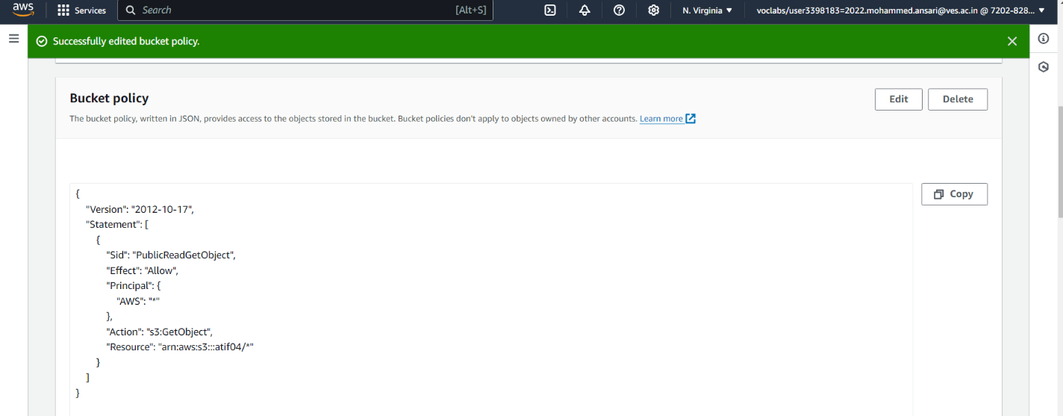

7. Go to the Objects section and select the index.html file. Then the Copy URL option will get activated. Click on it and paste it on the new tab.

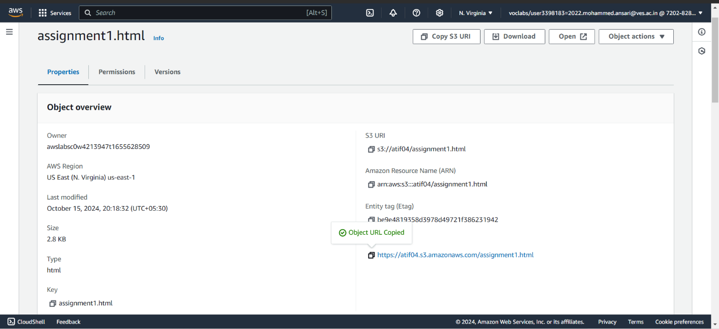

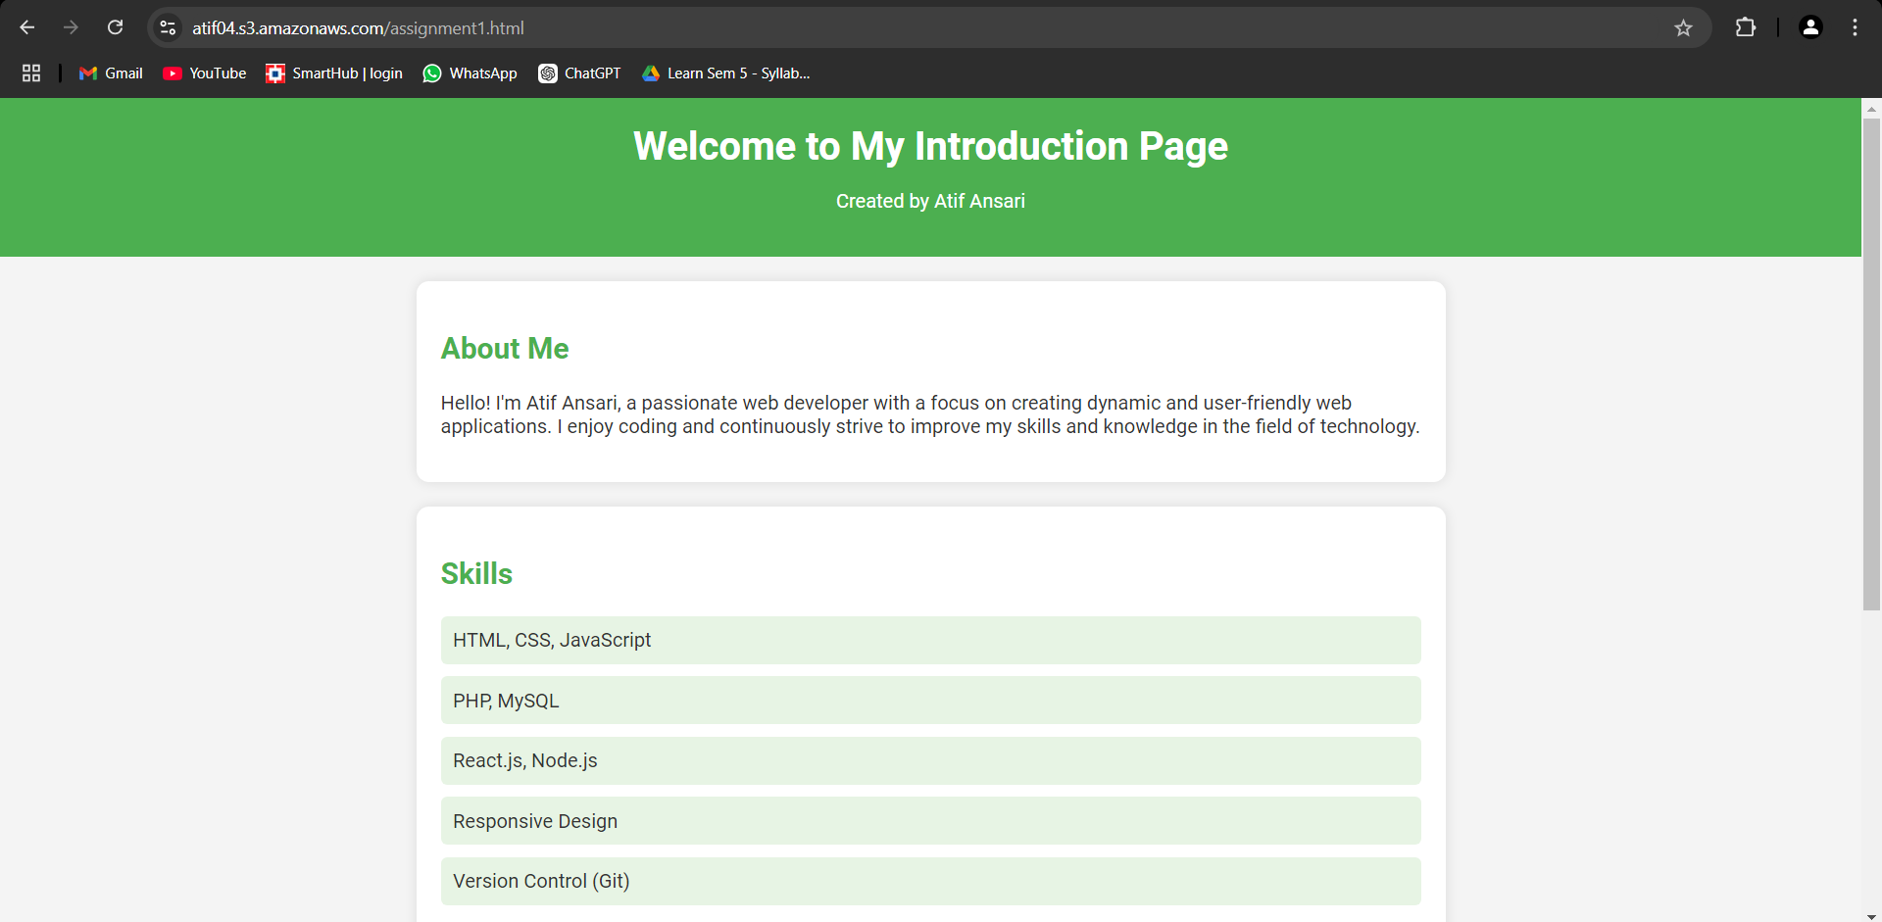

**Conclusion:** This experiment demonstrates the process of developing a website and the flexibility of hosting it on different platforms. Hosting on a local VM provides insights into infrastructure management, while hosting on AWS S3 showcases the benefits of cloud-based solutions. Understanding both approaches equips one with the skills to choose the appropriate hosting solution based on the project requirements and scalability needs.